A Project Proposal for the Bachelor’s in Computer Application

NEPSE TOOL



Name | Registration No. | Symbol No.
Raghav Panthi | 2023-1-53-0370 | 23530222
Shishir Devkota | 2023-1-53-0220 | 23530121
Shuprabha Mainali | 2023-1-53-0221 | 23530122

School of Environmental Science and Management Faculty of Science and Technology
Pokhara University, Nepal

May, 2025

Table of Content
LIST OF FIGURES | iii
LIST OF TABLES | iv
LIST OF ABBREVIATIONS | v
CHAPTER 1 | 1
INTRODUCTION | 1
1.1 Background | 1
1.2 Problem Statement | 2
1.3 Objectives | 2
CHAPTER 2 | 3
METHODOLOGY | 3
2.1 System Requirements | 3
2.1.1 Functional Requirements | 3
2.1.2 Non-Functional Requirements | 3
2.1.3 Requirement Prioritization Table | 4
2.2 Design | 5
CHAPTER 3 | 10
COST ESTIMATION AND PROJECT SCHEDULE | 10
3.1 Development Cost Estimation | 10
3.2 Project Schedule | 11
CHAPTER 4 | 12
EXPECTED OUTCOMES AND FUTURE WORK | 12
REFERENCES | 13

TOC \o "1-9" \u \l 1-9 \t "Heading 1,1,Heading 2,2,Heading 3,3,Heading 4,3" \h Table of Contents
LIST OF FIGURES 6
LIST OF ABBREVIATIONS 8
CHAPTER 1 1
INTRODUCTION 1
1.1 Background 1
1.2 Problem Statement 2
1.3 Objectives 2
CHAPTER 2 3
METHODOLOGY 3
2.1 System Requirements 3
2.1.1 Functional Requirements 3
2.1.2 Non-Functional Requirements 3
2.1.3 Requirement Prioritization Table 4
2.2 Design 5
Figure 2.1: Use Case Diagram of Nepse analysis system 5
Figure 2.2: ER Diagram of nepse ai 7
Figure 2.3: Flow Chart of nepseai 8
Figure 2.4: Sequential Diagram of nepseai 9
CHAPTER 3 10
COST ESTIMATION AND PROJECT SCHEDULE 10
3.1 Development Cost Estimation 10
3.2 Project Schedule 11
Figure 3.2: Gantt Chart 11
CHAPTER 4 12
EXPECTED OUTCOMES AND FUTURE WORK 12
REFERENCES 13

LIST OF FIGURES
Figures Page No.
Figure 2.1: Use Case Diagram of Nepse analysis system 5
Figure 2.2: ER Diagram of nepse ai 7
Figure 2.3: Flow Chart of nepseai 8
Figure 2.4: Sequential Diagram of nepseai 9
Figure 3.2: Gantt Chart 11

LIST OF TABLES
Tables Page No.
Table 2.1: Requirement Prioritization Table 4
Table 3.1: Development Cost Estimation Table 10

LIST OF ABBREVIATIONS

BCA | Bachelor’s in Computer Application
CSS | Cascading Style Sheet
CUI | Character User Interface
GUI | Graphical User Interface
IDE | Integrated Development Environment
JS | JavaScript
PU | Pokhara University
Regd. No. | Registration Number

CHAPTER 1

INTRODUCTION

Background
Nepal’s stock market, governed by Nepal Stock Exchange, has seen rapid growth in retail investors. However, most investors rely on basic platforms that only display stock prices without offering deeper insights.
Modern financial systems globally use data analytics and machine learning to help users understand market trends, predict stock behavior, and make informed decisions. In Nepal, such intelligent tools are still limited.
This project aims to bridge this gap by developing a web-based stock analysis system that provides visualization, analytics, and basic predictive features for NEPSE data.

Problem Statement
Despite the growing popularity of the Nepal Stock Exchange, existing platforms related to NEPSE primarily focus on providing basic stock information such as price and trading volume. These systems lack advanced analytical features, predictive capabilities, and intelligent insights that can assist users in understanding market trends. Furthermore, many of these platforms are not designed with beginner-friendly interfaces, making it difficult for new investors to interpret data effectively. As a result, users are often unable to make informed investment decisions due to the absence of meaningful analysis and decision-support tools. Therefore, there is a need for a system that not only presents stock data but also provides analytical insights and predictive features to help investors analyze trends and make better financial decisions efficiently.

Objectives
    - To develop a web-based system for visualizing stock data of the Nepal Stock Exchange.
    - To analyze stock trends using a Streamlit-based data analysis module
    - To integrate data visualization and analytical features into a single system.
    - To improve usability, accessibility, and user experience through a modern interface.
Key functionalities:

View Stock Data (Price, Volume, Trends)
Search and Filter Company Information
Visualize Data using Charts and Graphs
Analyze Trends using Streamlit Dashboard
Display Insights and Basic Predictions

CHAPTER 2

METHODOLOGY
Different steps were followed in order to develop the entire system. Here’s the breakdown of each of the phases.

System Requirements
We will conduct research to understand the needs of stock market users and investors who rely on the Nepal Stock Exchange for trading and analysis. Informal discussions with users and analysis of existing NEPSE-related platforms will help identify gaps such as lack of visualization and analytical tools. Existing systems will be studied to understand their limitations and areas of improvement. A feasibility study will be carried out considering technical, economic, and time constraints to ensure the successful development of the system.

Functional Requirements
Functional requirements define the main operations that the system must perform. The proposed system includes both a web-based visualization module and a Streamlit-based analysis module. These functionalities ensure that users can easily view and analyze stock data.
      - Display stock data (price, volume, trends)
      - Search and filter company information
      - Visualize stock data using charts and graphs
      - Perform trend analysis using Streamlit dashboard
      - Generate basic insights and analysis results
      - Load and process stock data from data sources

Non-Functional Requirements
Non-functional requirements focus on system performance, usability, and reliability. The system should provide a smooth and efficient user experience while handling stock data securely and accurately. [3].
      - Usability: Simple, clean, and user-friendly interface
      - Performance: Fast loading and responsive system
      - Reliability: Accurate data processing and visualization
      - Scalability: Ability to handle increasing data in future
      - Maintainability: Modular and well-documented code
      - Accessibility: Accessible through modern web browsers

Requirement Prioritization Table
This table categorizes system requirements based on importance and helps prioritize development tasks [4].

Requirement | Priority | Justification
Display Stock Data | High | Core functionality of the system
Data Visualization (Charts) | High | Essential for understanding trendsa
Search & Filter | High | Improves usability
Streamlit Analysis Module | High | Provides analytical insights
Trend Analysis | Medium | Enhances decision-making
Prediction Feature | Medium | Adds intelligence to system
Responsive Design | Low | Useful for mobile/tablet access but not critical for initial version
Error Handling | Medium | Improves reliability
Table 2.1: Requirement Prioritization Table

Design
In this phase, the system architecture and components are designed. The project follows a modular approach by separating the visualization and analysis components.
- Frontend: HTML/CSS for structure and style, JavaScript for dynamic behavior and form validation.
- Backend: Flask / Node.js for handling requests and data processing

- Data Analysis: Python with Pandas, Matplotlib, and Streamlit

- Visualization: Chart.js or similar libraries

- Architecture: Modular architecture (Web App + Streamlit Analysis Module)
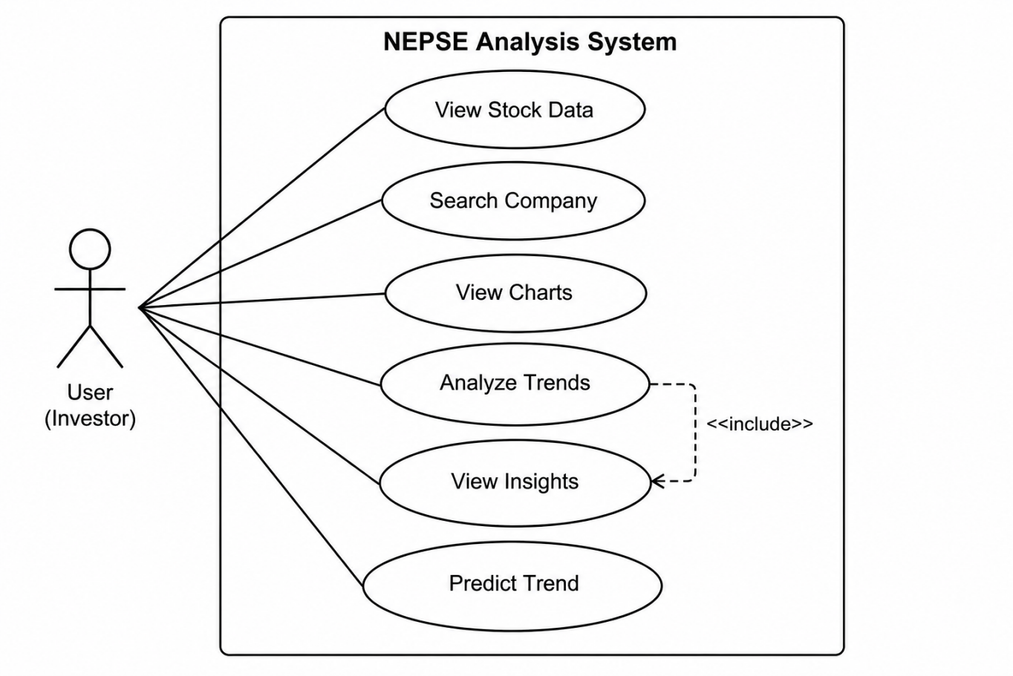

Figure 2.1: Use Case Diagram of Nepse analysis system

This use case diagram represents the functionality of a NEPSE Analysis System from the perspective of a User (Investor). The User is the primary actor in the system and interacts with various features designed to analyze stock market data from the Nepal Stock Exchange.The diagram illustrates several actions (use cases) that the User can perform. These include viewing stock data, searching for a specific company, viewing graphical charts, analyzing market trends, viewing insights, and predicting future trends. Each of these use cases helps the investor make informed decisions based on available data and analytical tools. Additionally, there is an <> relationship between Analyze Trends and View Insights. This indicates that whenever the User performs trend analysis, the system automatically includes the process of generating insights. In other words, insights are a necessary part of analyzing trends and are always provided as part of that functionality.
Overall, the diagram shows how the User interacts with the NEPSE Analysis System to explore stock information, analyze market behavior, and make predictions, enabling more effective and data-driven investment decisions.

Figure 2.2: ER Diagram of nepse ai

This diagram is an Entity-Relationship Diagram (ERD) that shows the relationship between the Admin and Student in e-RecordBook. In the diagram, there are two main entities: Admin and Student. The Admin entity has three attributes: admin_id (which is the primary key), username, and password. These are used to identify and authenticate the admin. The Student entity has several attributes: student_id (primary key), name, date of birth (dob), temporary address, permanent address, parents name, contact number, email, faculty, semester, and enrolled courses. These attributes store the important information about each student. The diagram also shows that an Admin manages the Student records, which means the admin is responsible for adding, updating, viewing, and deleting student information. This ERD helps to clearly understand how data is structured and how the Admin interacts with the Student records in the system.

Figure 2.3: Flow Chart of nepseai

The process begins by checking if the Admin is registered. If registered, the Admin can log in directly; otherwise, they must register first and then proceed to login. After logging in, the Admin accesses the dashboard and selects an operation to perform. To add a student, the Admin enters student details and saves them to the database. For searching, a query is entered, and the matching student information is displayed. To update a record, the Admin selects a student, edits the details, and updates them in the database. For deletion, the Admin selects the student, confirms, and deletes the record. If an invalid operation is selected, the system shows an error and redirects to the operation menu. After each task, the system asks if more operations are needed. If yes, the Admin continues; if no, they log out and exit the system.

Figure 2.4: Sequential Diagram of nepseai

This diagram shows the steps an Admin takes to add a new student to the system. First, the Admin enter their username and password on the login page. The system sends this information to the server to check if it’s correct. If the login is successful, the Admin gets access to the system. Then, the Admin goes to the 'Add Student' section from the dashboard. The system opens the student entry form. The Admin fills the student’s details and submits the form. The system saves this information in the database. Once the student is added, the system sends a message back saying "Student Added Successfully."

CHAPTER 3

COST ESTIMATION AND PROJECT SCHEDULE

Development Cost Estimation

Item | Description | Estimated Cost
Development Time (Approx. 120 hrs.) | 3 members * 30 hrs. @ Rs. 0/hour (Effort only) | Rs. 0
Laptop/PC Usage | Personal laptops used for  development | Rs. 0
Internet Charges | Home Wi-Fi | Rs. 0
Software Tools | VS Code, XAMPP, MySQL, Java SDK, Bootstrap (free tools) | Rs. 0
UI/UX Design Tools | Figma / Canva (Free versions) | Rs. 0
Hosting/Server | Local server used for development and testing | Rs. 0
Printing, documentation | Rs. 5/paper and Rs. 30 for binding | Rs. 500  (approx.)
Table 3.1: Development Cost Estimation Table

Project Schedule
A project schedule Gantt chart is a visual tool that shows the timeline of a project. Tasks are listed vertically, and the time is displayed horizontally. It helps track progress, manage deadlines, and see task dependencies easily [7].

Figure 3.2: Gantt Chart

This project will begin with the Requirement Analysis phase from May 15 to May 19, where initial system needs are identified. This will be immediately followed by the Design phase, which runs until May 23 and focuses on outlining the structure of the system. After the design is completed, three development processes—Frontend Development, Backend Development, and ai Integration will start simultaneously on May 23. Frontend development will conclude on May 31, database integration will be finished by May 28, and backend development will continue until June 2. To ensure quality, Testing and Debugging will also begin concurrently on May 23 and runs continuously, covering all development activities throughout the project period. Once the testing is complete, the system will enter the Deployment phase from June 9 to June 12, where the application will be hosted on local server and made operational. Finally, the project will conclude with a Final Review conducted from June 12 to June 14 to assess the outcomes and finalize documentation.

CHAPTER 4

EXPECTED OUTCOMES AND FUTURE WORK
The proposed NEPSE Stock Analysis System, developed using web technologies and Python-based analytical tools, is expected to address the limitations of existing stock platforms by providing both data visualization and analytical insights. The system will offer a centralized platform where users can easily access stock data, visualize trends through interactive charts, and perform analysis using the integrated Streamlit module. This will improve users’ ability to understand market behavior, reduce reliance on raw data interpretation, and support better investment decision-making. The system is expected to enhance usability, efficiency, and accuracy while providing a modern and user-friendly interface for analyzing Nepal Stock Exchange data.
Looking ahead, several enhancements can be incorporated to further improve the system. One major future scope is the integration of advanced machine learning models for more accurate stock price prediction and automated buy/sell recommendations. The system can also be extended to include portfolio management features, allowing users to track their investments and analyze profit or loss. Additionally, real-time data integration and news sentiment analysis can be implemented to provide more dynamic and intelligent insights. Developing a mobile application version of the system will further increase accessibility and user engagement.
This project is expected to evolve into a comprehensive stock analysis platform tailored for the Nepalese market. By combining web-based visualization with data analytics, the system will provide a complete solution for stock market analysis. The development process will also provide practical experience in full-stack development and data science integration. With continuous improvements, the system can be scaled and adapted to meet the growing needs of investors and the evolving financial ecosystem.

REFERENCES
- A. Smith, B. Johnson, and L. Lee, “Web-based Student Information Management Systems: A Review,” International Journal of Educational Technology, vol. 14, no. 2, 2021.
- K. Patel and S. Joshi, Developing Student Management Systems Using Java and MySQL, New Delhi: TechnoPress, 2020.
- H. Chen and M. Wang, “Scalable Web Technologies in Academic Administration,” Computers & Education, vol. 98, pp. 44–53, 2022.
- S. Kumar and R. Singh, “Functional and Non-functional Requirements in Educational Web Systems,” Software Engineering Review, vol. 11, no. 3, pp. 121–130, 2021.
- Vidyalaya School Software, “Advantages of Student Record Management System,”
Feb. 2024. [Online]. Available: https://www.vidyalayaschoolsoftware.com/blog/

- Sparkrock, “Top 10 Benefits of a Student Management System,” Nov. 2024. [Online]. Available: https://sparkrock.com/blog/
- J. Thomas and R. Brown, “Scheduling Tools for Educational IT Projects,” International Journal of Project Management, vol. 12, no. 4, pp. 33–39, 2019.

